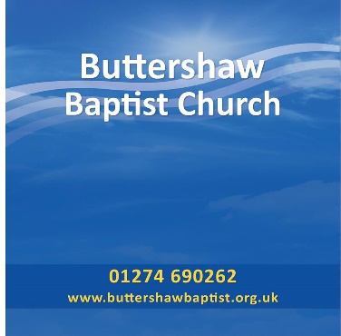BETHEL SOZO UKMINISTRY APPLICATION*

Please print your details. We will use these details to contact you and to book an appointment. Once you have attended your ministry session, this form and any emails will be destroyed.

Date of Application_______________________________________________________________

Name __________________________________________________________________________

Address ________________________________________________________________________

______________________________________________ Post Code ________________________

Email ___________________________________________________________________________

Contact Number ____________________________________________________________

Gender (Male/Female/other [please state]) ____________________________________________

Are you attending a church? ________________________________________________________

Why would you like to receive a sozo?_________________________________________________

________________________________________________________________________________

________________________________________________________________________________

Who referred you to the Bethel Sozo UK Ministry?_____________________________________

________________________________________________________________________________

Please let us know time you can’t do: _____________________________________________________________________________

________________________________________________________________________________

We recommend that you share with someone you trust what happened during your ministry time so that you will have someone to pray with and walk with you through your journey to wholeness (this person should not be someone you consider you “best friend”).

It can be helpful to fast or pray during the week before your session.

In order for us to resource and develop this ministry you may like to give a donation. Please either post or email your application form to us at:

* Sozo Team, Buttershaw Baptist Church, The Crescent, Bradford, BD6 3PZ
* [healing@buttershawbaptist.org.uk](mailto:healing@buttershawbaptist.org.uk)

*Note: The Sozo Ministry used is modelled on the Sozo Ministry of the Transformation Centre at Bethel Church, Redding CA 96003, USA (www.ibethel.org)

Buttershaw Baptist Church, (CIO 1168084 since July 2016), The Crescent, Bradford, BD6 3PZ.

www.buttershawbaptist.org.uk