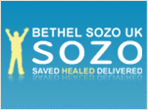
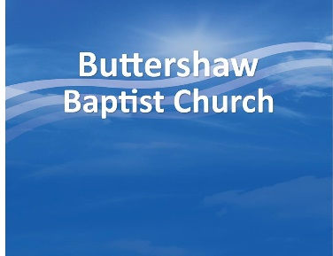
Forgiveness – the key to freedom

During your upcoming sozo, it is very important that you prepare your heart to forgive those who have wronged you. Most people do not understand what forgiveness is and they have a hard time forgiving those who have deeply wounded and hurt them.

They will say: “well, it wasn’t fair… it wasn’t right!” … Or question: “How can I forgive? They do not deserve it”.

If these responses sound familiar, and express how you feel, you should know that:
- Forgiveness does not mean that what they did to you was right
- Forgiveness does not mean that they “get off free”
- Forgiveness does not mean you give up all your rights
Unforgiveness:
- Does not hurt the one who harmed you
- It hurts only you
- Binds you in a prison of torment
- Often causes you to have bitterness, hatred and anger
- Blocks the fullness of God in your life
Extending forgiveness does the following wonderful things:
- You get to step out of the way & let God have a direct line to that person
- It means you are relieved of the burden you have been carrying
- It frees you from a prison of torment
- It closes a door which allows the enemy to have access to you
- It allows you to say:
    - “I choose to give grace”
    - “I choose to let this person go into God’s hands”
    - “I am not going to be their judge”

Take a few moments to reflect on the following scriptures:
Matthew 6:14-15; “For if you forgive men when they sin against you, your heavenly Father will also forgive you. But if you do not forgive men their sins, your Father will not forgive your sins.”

Matthew 18:21-35; This is the story of the servant, who would not forgive. After he was forgiven much, the master tells him; “‘Shouldn’t you have had mercy on your fellow servant, just as I had on you?’ In anger his master turned him over to the jailers (tormentors) to be tortured, until he should pay back all he owed. This is how my heavenly Father will treat each of you unless you forgive your brother from your heart.” (v.33-35)

Luke 6:37; “Do not judge and you will not be judged. Do not condemn, and you will not be condemned. Forgive, and you will be forgiven.”

Forgiveness is a command from the Lord.
Because Jesus freely forgave us for all our sins, we must also freely forgive.
Forgiveness is a choice, not a feeling.
Forgiveness is vital to deliverance & freedom.

Buttershaw Baptist Church, (CIO 1168084 since July 2016), The Crescent, Bradford, BD6 3PZ.
www.buttershawbaptist.org.uk

