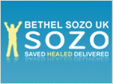
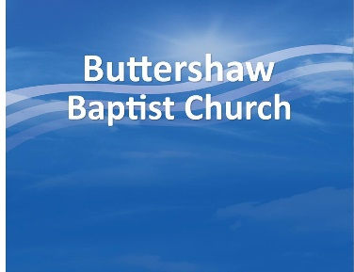

Bethel Sozo UK Optional Questionnaire

Your Name: ________________________________ Date of Session:_________

Team in the session:

1st: ____________________ 2nd: _____________________ 3rd: _____________________

1. How did you find it?
Very Helpful? __ Helpful? __ Neither Helpful/Unhelpful? __ Unhelpful? __

2. How would you describe your experience? (Continue overleaf if necessary)

______________________________________________________________________________
______________________________________________________________________________

3. Were there any issues that concerned you about your ministry time? (Continue overleaf if necessary)
______________________________________________________________________________
______________________________________________________________________________
______________________________________________________________________________

4. Did you experience a personal breakthrough during or after the ministry? _________________

5. How have you benefited from this ministry time? _____________________________________
______________________________________________________________________________
______________________________________________________________________________
______________________________________________________________________________

Buttershaw Baptist Church, (CIO 1168084 since July 2016), The Crescent, Bradford, BD6 3PZ.
www.buttershawbaptist.org.uk

6. Were the ministry team members:
- Kind and understanding in their interactions with you? Yes ___ No ___
- Knowledgable about the process? Yes ___ No ___
- Safe to disclose personal hurts, shame or struggles with? Yes ___ No ___ N/A ___

7. Would you recommend a Sozo session to others?
- Actively recommend ___
- Recommend if asked ___
- Wouldn’t recommend ___

8. Any comments or suggestions? (Continue overleaf if necessary)
______________________________________________________________________________
______________________________________________________________________________
______________________________________________________________________________
______________________________________________________________________________

9. May we quote from your testimony anonymously for the encouragement of others?
Yes ___ No___

Please return this form at your convenience to: Sozo Administrator, Buttershaw Baptist Church, The Crescent, Buttershaw, Bradford, BD6 3PZ or email to healing@buttershawbaptist.org.uk
This form will be destroyed after the useful information has been extracted.

Buttershaw Baptist Church, (CIO 1168084 since July 2016), The Crescent, Bradford, BD6 3PZ.
www.buttershawbaptist.org.uk

